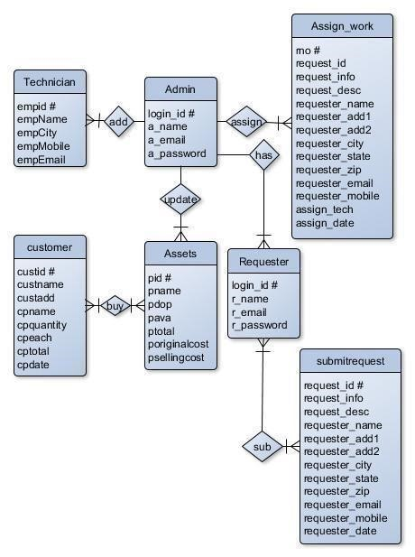

**Table Name: adminlogin_tb**

|  |  |  |
| --- | --- | --- |
| **Attribute** | **Data Type** | **Description** |
| a_login_id # | int | Stores login id (Automatically Generated) |
| a_name | varchar(60) | Stores Name |
| a_email | varchar(60) | StoreEmail |
| a_password | varchar(60) | Store Password |

**Table Name: requesterlogin_tb**

|  |  |  |
| --- | --- | --- |
| **Attribute** | **Data Type** | **Description** |
| r_login_id # | int | Stores login id (Automatically Generated) |
| r_name | varchar(60) | Stores Name |
| r_email | varchar(60) | StoreEmail |
| r_password | varchar(60) | Store Password |

**Table Name: customer_tb**

|  |  |  |
| --- | --- | --- |
| **Attributes** | **Data Type** | **Description** |
| custid # | int | Customer ID (Automatically Generated) |
| custname | varchar(60) | Customer Name |
| custadd | varchar(60) | Customer Address |
| cpname | varchar(60) | Product Name |
| cpquantity | int | Product Quantity |
| cpeach | int | Each Quantity Price |
| cptotal | int | Total Price |
| cpdate | date | Selling Date |

**Table Name: assets_tb**

|  |  |  |
| --- | --- | --- |
| **Attributes** | **Data Type** | **Description** |
| pid # | int | Product ID (Automatically Generated) |
| pname | varchar(60) | Product Name |
| pdop | date | Product Date |
| pava | int | Number of Available Product |
| ptotal | int | Number of Total Product |
| poriginalcost | int | Product Original Cost |
| psellingcost | int | Product Selling Price |

**Table Name: submitrequest_tb**

|  |  |  |
| --- | --- | --- |
| **Attributes** | **Data Type** | **Description** |
| request_id # | int | Request ID (Automatically Generated) |
| request_info | text | Request Info |
| request_desc | text | Request Description |
| requester_name | varchar(60) | Requester Name |
| requester_add1 | text | Requester Address Line 1 |
| requester_add2 | text | Requester Address Line 2 |
| requester_city | varchar(60) | Requester City |
| requester_state | varchar(60) | Requester State |
| requester_zip | int | Requester Zip |
| requester_email | varchar(60) | Requester Email |
| requester_mobile | bigint | Requester Mobile |
| request_date | date | Request Date |

**Table Name: assignwork_tb**

|  |  |  |
| --- | --- | --- |
| **Attributes** | **Data Type** | **Description** |
| rno # | int | Request Number (Automatically Generated) |
| request_id | int | Request ID |
| request_info | text | Request Info |
| request_desc | text | Request Description |
| requester_name | varchar(60) | Requester Name |
| requester_add1 | text | Requester Address Line 1 |
| requester_add2 | text | Requester Address Line 2 |
| requester_city | varchar(60) | Requester City |
| requester_state | varchar(60) | Requester State |
| requester_zip | int | Requester Zip |
| requester_email | varchar(60) | Requester Email |
| requester_mobile | bigint | Requester Mobile |
| assign_tech | varchar(60) | Assign Technician Name |
| assign_date | date | Assigned Date |

**Table Name: technician_tb**

|  |  |  |
| --- | --- | --- |
| **Attributes** | **Data Type** | **Description** |
| empid # | int | Employee ID (Automatically Generated) |
| empname | varchar(60) | Employee Name |
| empcity | varchar(60) | Employee City |
| empmobile | bigint | Employee Mobile Number |
| empemail | varchar(60) | Employee Email ID |